CS2023 - Data Structures and Algorithms Take Home Assignment

Week 9 - Graphs

Submission by: Sajeev Kugarajah (210554M)

# Questions

1. Represent the graph given below (Fig.1) as Adjacency Matrix, Adajacency List and COO format (read about COO format and attempt)

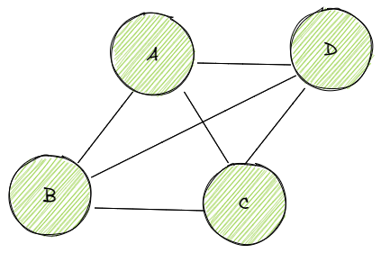

Figure 1: Graph for Question 1

**Adjacency Matrix :-**

|  |  |  |  |  |
| --- | --- | --- | --- | --- |
|  | **A** | **B** | **C** | **D** |
| **A** | 0 | 1 | 1 | 1 |
| **B** | 1 | 0 | 1 | 1 |
| **C** | 1 | 1 | 0 | 1 |
| **D** | 1 | 1 | 1 | 0 |

**Adjacency List :-**

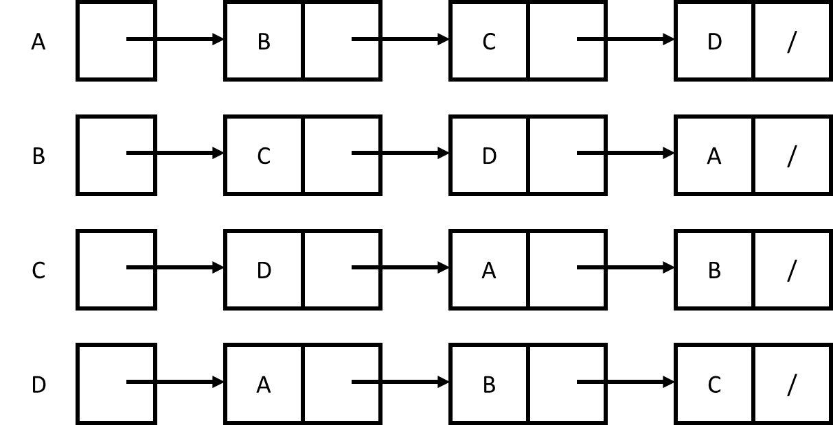

**COO Format :-**

rows = [A, A, A, B, B, B, C, C, C, D, D, D]

columns = [B, C, D, A, C, D, A, B, D, A, B, C]

values = [1, 1, 1, 1, 1, 1, 1, 1, 1, 1, 1, 1]

1. By observing the answers in Question 1, which representation is the best choice? and provide why you chose this.

Adjacency matrix is the best choice for this question, since the graph is a dense graph it’s efficient to represent it as an adjacency matrix instead of other formats.

1. Write a pseudo code for BFS.

Input: s as the source node

BFS (G, s)

let Q be queue.

Q.enqueue( s )

mark s as visited

while ( Q is not empty)

v = Q.dequeue( )

for all neighbors w of v in Graph G

if w is not visited

Q.enqueue( w )

mark w as visited

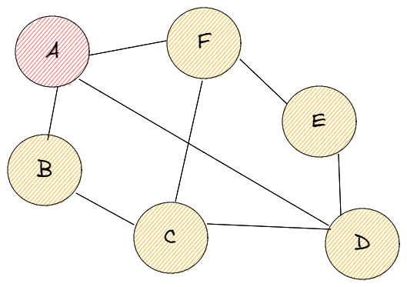

Figure 2: Graph for Question 4

1. What will be the BFS and DFS output for graph (Fig.2) taking “A” as the start node?

BFS = A, B, D, F, C, E

DFS = A, B, C, D, E, F